**DBMS LAB-1**

**NAME: RAGINI SHARMA**

**ID: B120062**

**1. Use of CREATE command.**

1. Syntax: CREATE TABLE Persons (PersonID int, LastName varchar(255), FirstName varchar(255), Address varchar(255), City varchar(255)); **CODE:**

CREATE TABLE Persons(

PersonId int,

LastName varChar(255),

FirstName varchar(255),

Address varchar(255),

City varchar(255)

);

**OUTPUT:**

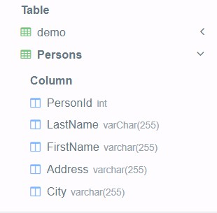

1. Create a table whose details are given below.
   1. Name of Table: COLLEGE ii. Attributes are: CNAME(char), LOCATION(char)  **CODE:**

create table COLLEGE( CNAME CHAR(255),

LOCATION CHAR(255) );

**OUTPUT:**

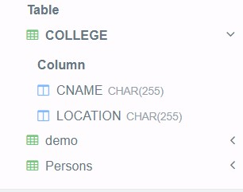

1. Create a table whose details are given below. 
   1. Name of Table: FACULTIES ii. Attributes are: FNAME(char), DEPT(char),DESGN(char)  **CODE:**

CREATE TABLE FACULTIES (

FNAME char(255),

DEPT CHAR(255),

DESGN CHAR(255));

**OUTPUT:**

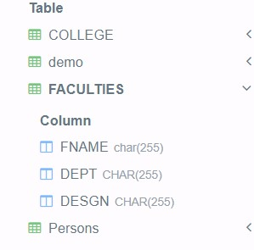

1. Create a table whose details are given below.

i. Name of Table: CUSTOMER ii. Attributes are: CNAME(char), CID(int), ITEMNAME(char),PRICE(int)

**CODE:**

CREATE TABLE CUSTOMER (

CNAME char(255),

CID INT,

ITEMNAME CHAR(255),

PRICE INT);

**OUTPUT:**

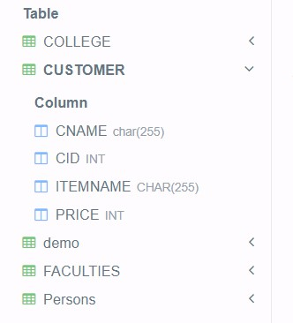

1. Create a table whose details are given below.
   1. Name of Table: STUDENTS
   2. Attributes are: SNAME (char),ROLL(char),BRANCH(char),SUBJ1(int), SUBJ2(int).

**CODE:**

CREATE TABLE STUDENTS (

SNAME char(255),

ROLL CHAR(255),

BRANCH char(255),

SUBJ1 INT,

SUBJ2 INT

);

**OUTPUT:**

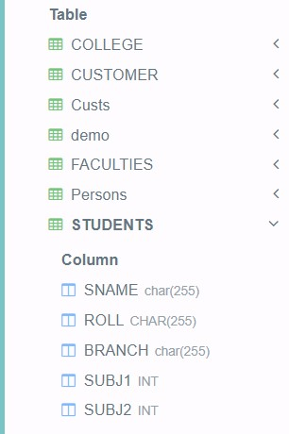

**2. Use of INSERT command.**

a. Syntax: INSERT INTO Custs (CustomerName, ContactName, Address, City,

PostalCode, Country) VALUES ('Cardinal', 'Tom B. Erichsen', 'Skagen 21', 'Stavanger', '4006', 'Norway');

**CODE:**

CREATE TABLE Custs(

CustomerName char(255),

ContactName Char(255),

Address CHAR(255),

City CHAR(255),

PostalCode INT,

Country CHAR(255));

INSERT INTO Custs (CustomerName, ContactName, Address, City, PostalCode, Country) VALUES ('Cardinal', 'Tom B. Erichsen', 'Skagen 21', 'Stavanger', '4006', 'Norway');

SELECT*FROM Custs;

**OUTPUT:**



1. INSERT into a table whose details are given below.

i. Name of Table: COLLEGE ii. Attributes are: CNAME(IIIT), LOCATION(Bhubaneswar) **CODE:**

INSERT INTO COLLEGE VALUES('IIIT','Bhubaneswar');

SELECT*FROM COLLEGE;

**OUTPUT:**



1. INSERT into a table whose details are given below.

i. Name of Table: FACULTIES ii. Attributes are: FNAME(A Kalam), DEPT(CSE),DESGN(Professor) **CODE:**

INSERT INTO FACULTIES VALUES('A Kalam','CSE','Professor');

SELECT*FROM FACULTIES;

**OUTPUT:**

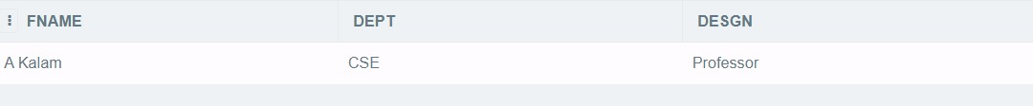

d. INSERT into a table whose details are given below.

i. Name of Table: CUSTOMER ii. Attributes are: CNAME(Dhruv Rathee), CID(700), ITEMNAME(Camera),PRICE(50000)

**CODE:**

INSERT INTO CUSTOMER VALUES('Dhruv Rathee','700','Camera','50000');

SELECT*FROM CUSTOMER;

**OUTPUT:**



e. INSERT into a table whose details are given below.

i. Name of Table: STUDENTS ii. Attributes are: SNAME (ADITYA), ROLL(b1111), BRANCH(CSE),SUBJ1(75), SUBJ2(85).

**CODE:**

INSERT INTO STUDENTS VALUES('ADITYA','b1111','CSE','75','85');

SELECT*FROM STUDENTS;

**OUTPUT:**



**3. Use of ALTER command**

a. ADD Column to a table using following details

i. Name of Table: COLLEGE ii. Column name: CTYPE (char) iii. Syntax: ALTER TABLE table_name ADD column_name datatype; **CODE:**

ALTER TABLE COLLEGE ADD CTYPE CHAR(255);

**OUTPUT:**

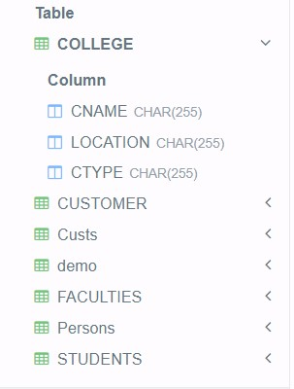

b. DROP COLUMN of a table using following details

i. Name of Table: FACULTIES ii. Column name: DESGN iii. Syntax: ALTER TABLE table_name DROP COLUMN column_name; **CODE:**

ALTER TABLE FACULTIES DROP desgn ; **OUTPUT:**

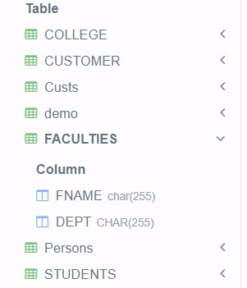

c. MODIFY COLUMN of a table using following details

i. Name of Table: COLLEGE ii. Column name: CTYPE (int)

1. Syntax-1: ALTER TABLE table_name ALTER COLUMN column_name datatype;
2. Syntax-2: ALTER TABLE table_name MODIFY COLUMN column_name datatype;
3. Syntax-3: ALTER TABLE table_name MODIFY column_name datatype; **CODE:**

ALTER TABLE COLLEGE modify ctype int;

**OUTPUT:**

